EXP 36

AIM: Design NFA using simulator to accept the string the start with a and end with b over

set {a,b} and check W= abaab is accepted or not.

INPUT:

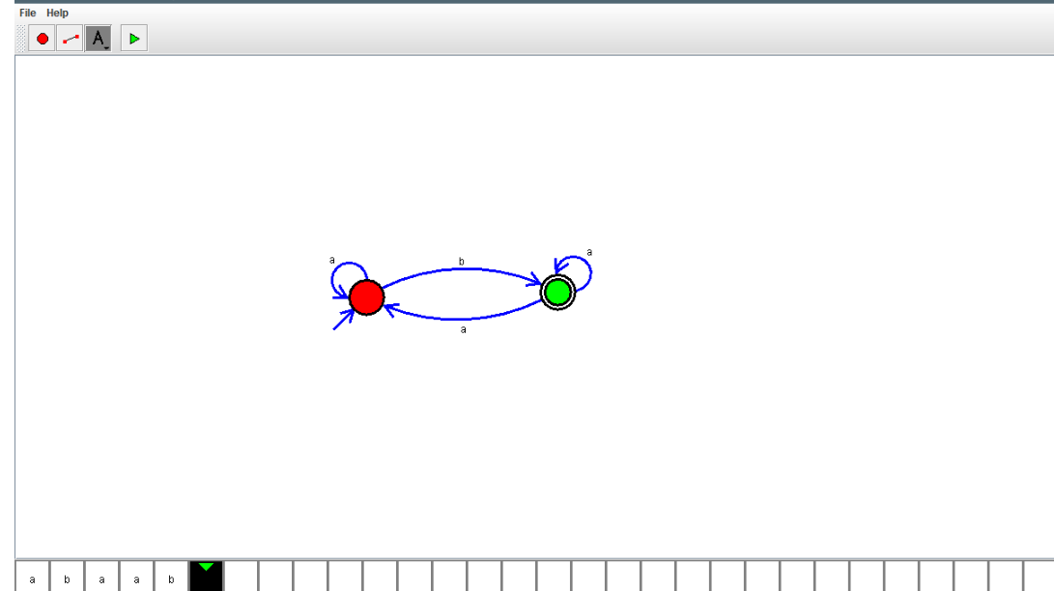

OUTPUT:



RESULT: NFA using simulator to accept the string the start with a and end with b over

set {a,b} and check W= abaab is accepted or not is verified